LABORATORY # 03

Part 1: Op-Amp Integrator and Differentiator Circuits

Purpose
The goal of this laboratory is to examine the circuit characteristics of the Op-Amp Integrator and Op-Amp Differentiator circuits.

Theoretical Background

Integrator
If the resistor is replaced by a capacitor in the negative feedback loop in the basic Inverting Op-Amp configuration, a simple integrator circuit can be realized. The basic configuration is shown in Figure 3.1. Once an input signal is applied, the output will appear as an integration of input. The integrator’s output voltage can be written as

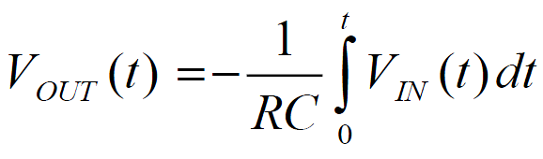

In this equation, it assumes that initially there is no charge on the capacitor.

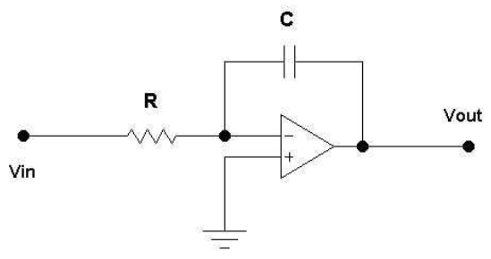

Figure 3.1

The integrator is useful for turning square waves into triangular waves, and triangular waves into sine waves.

Differentiator
A differentiator circuit can be achieved by replacing the resistor with a capacitor at the input of a basic Inverting Op-Amp configuration. This configuration is shown in Figure 3.2. The differentiator output voltage can be written as

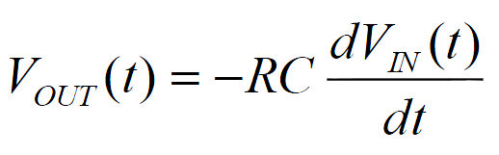

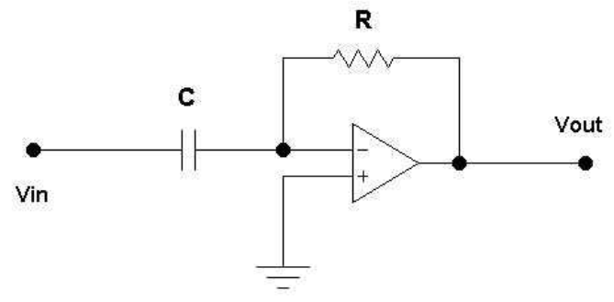
Figure 3.2

Notice that according to above mentioned equation, the differentiator does the opposite of the integrator.

Simulation Section Electronic EWB (Multisim):

Integrator
(Refer to Figure 3.1)
Let R=1K Ohm, C=3.3 µF, f = 1K HZ,
VIN = 1Vpp sinusoidal.
VIN = 1Vpp triangle.
VIN = 1Vpp square.

- Plot the input and output waveforms on the same graph for one complete cycle.

Differentiator
(Refer to Figure 3.2)
Repeat all steps as mentioned for integrator.

Some exemplary results are shown below for information purpose ONLY.

Laboratory Procedure: Use +/- 15 Volts to power Op-Amp.

Build both Integrator and Differentiator circuits in the lab. Repeat all the steps from the Simulation section. Compare your results with Simulation sections. Comment and explain any discrepancies. Use the same voltage and resistance values that were used in the simulation.
Be sure to save all the waveforms from your oscilloscope.

